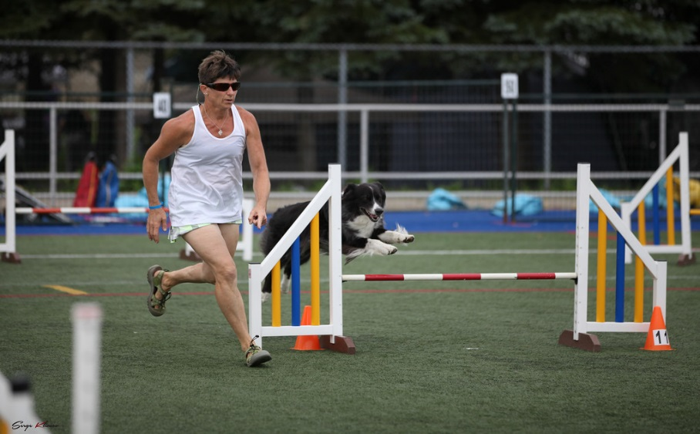
Martha Fortier
I started agility classes in 2005, caught the agility bug, and had my first competition in 2008. My first agility dog, Ishta, did not love the sport as much as I did but my other dogs have done very well. I have ATChC’d 5 dogs and with two of my teammates, have achieved Lifetime Award of Merit and Versatility
Lifetime Award of Merit.
I stated judging in April 2017 and for me it is a privilege, a challenge and a pleasure. I love to promote the sport and want everyone to feel welcome and encouraged when they compete in my ring especially the rookie handlers and rookie dogs. To watch teams, whom have struggled with certain issues, succeed,
is such a thrill for me and starter dogs can be very entertaining!
I grew up with dogs my whole life, in and around the West Island of Montreal, and due to one of my parent’s nervous dogs decided to change my life and opened up Martha’s Menagerie, a local kennel that emphasizes socialization for the canine companion, for over 21 years ago. Being the owner/manager of Martha’s Menagerie, I have helped clients with difficult dogs as well as boarding dogs and including exercise where the boarders are walked 3-4 times a day in the back of the property, with most being off leash. Having over 20 dogs interacting off leash with each other on a weekly basis has provided a lot of experience and am well versed on dog behaviour and dog language.
I currently share my home with 4 Australian Shepherds and 1 All-Canadian but love all breeds of dogs.

