AAC Sanctioned Agility Trial

July 30th – August 1st, 2021
Judges: Christine Mandy & Brian Wickenheiser

Location: Big Sky Dog Centre, 4445 Florida Road, Harrowsmith, ON K0H 1V0

Friday, July 30th - 2 SC, 2 TR
Saturday, July 31st – Starters & Masters
Sunday, August 1st - Advanced & Masters

LIMITED TRIAL ENTRY
Given the ever-changing circumstances of the pandemic, we may amend limitations and protocols as necessary.

Opening Date for Entries: Monday, June 28, 2021
Closing Date for Entries: Monday, July 26, 2021 (or when trial is full)

One outdoor fenced ring. Grass surface. Rubberized contacts. Electronic Timing.
Arrival & Set-up
Friday: 12:00 p.m. Set-Up | 1:00 p.m. First Dog on the Line
Saturday: 8:00 a.m. Set-Up | 9:00 a.m. First Dog on the Line
Sunday: 8:00 a.m. Set-Up | 9:00 a.m. First Dog on the Line

CONTACT: Trial Secretary: Nancy Wightman agilityconnection@outlook.com

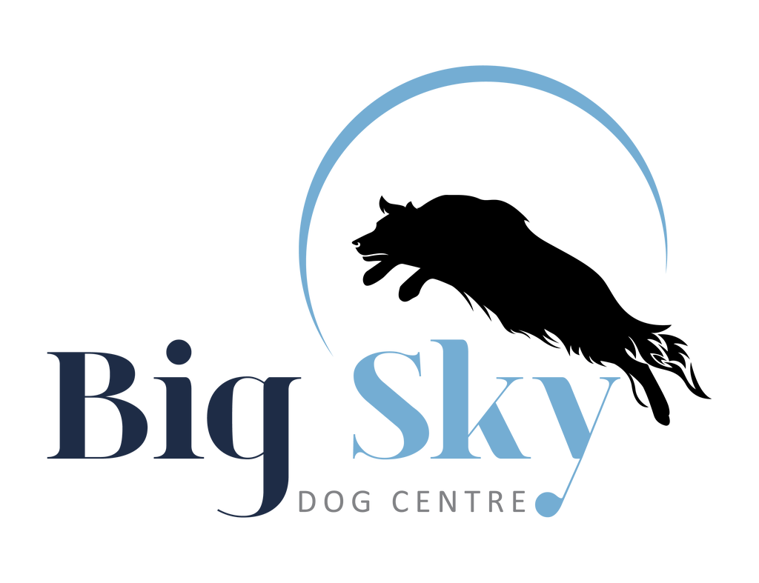
Trial Procedures in Place During the COVID-19 Pandemic
Hello everyone! We are trying very hard to offer a safe and enjoyable agility experience. However, it’s going to take the cooperation of everyone involved to make this a success. So we’ve implemented a list of rules in order to open. You will see that some things are temporarily changed. If you disagree with any of the new rules please come back when things are back to usual.
COVID RULES:
- STAY HOME IF YOU ARE FEELING SICK!!!! Here is the link to Ontario’s COVID 19 Self-Assessment Tool: https://covid-19.ontario.ca/self-assessment/ Please take the assessment on the morning of the event.
- DISINFECT YOUR HANDS REGULARLY. Refrain from touching your face.
- Follow all Provincial and Municipal guidelines with regard to COVID-19 precautions.
- Please refrain from touching anything that isn’t yours. Stay on guard against touching anything that may have been touched by others. Carry your own hand sanitizer or wipes – and USE THEM!
- Maintain social/physical distance.
- If you feel more comfortable wearing a mask, please bring your own. Provincial guidelines recommend wearing a mask when social distancing cannot be maintained. Please be advised that we will not be providing masks or gloves to competitors.
- Gloves are an individual choice. Studies show frequent hand washing is better than gloves in most cases. If you do wear gloves be VERY aware of not touching anything else during that time. If you prefer to wear gloves, you will need to bring enough pairs for the times you will need to wear them.
- NOTE CHANGE: Competitors may be accompanied by members of their same household.
- Please use hand sanitizer when entering the ring to volunteer and again when you leave the ring. Hand sanitizer will be available at the outside of the ring.
- Bring your own food, snacks, water, drinks, etc.
- Make sure your dog is ok with people wearing masks. We don’t want a dog becoming fearful due to something they’ve never seen before.

Be respectful to everyone! Be patient with everyone! Follow all trial rules and health precautions!

TRIAL PROCEDURES:
- YOU MAY SET UP in your car or in a shade tent. In both cases, be sure to maintain safe social distancing.
- COURSE MAPS will be emailed 2 hours prior to the start of the first event of the trial. They will also be posted outside the building so you can take a photo with your phone. Do not crowd the map location.
- GENERAL BRIEFING will be on Facebook and emailed before the trial.
- JUDGE’S BRIEFINGS: The judge will specify a location at the site to answer questions during each walk through, keeping physical distancing in mind.
- RUNNING ORDERS: Running Orders will be emailed with the final confirmation.
- WALK-THROUGHS may be divided into groups. They will be 5 minutes each. FACE MASKS ARE MANDATORY DURING WALK THROUGHS.
- GATE STEWARD & CHECK IN: There is no check in at the gate. The Gate Steward will call out during the walk through to check-in dogs. (Gate stewards, please try to bring your own pen/marker for check-in.) As the Gate Steward will not be at the gate, it is the handler’s responsibility to be on time and ready for your run. Be sure to maintain your Physical Distance from everyone in the area!
- THERE IS NO LEASH RUNNER. Throw your leash along the fence line toward the exit gate, place it on the table or put it in your pocket. Walk or carry your dog to the start. Ensure your dog is on leash before you leave the ring.
- TIMER & SCRIBE: The scribe and timer must sanitize their hands before and after working, and wear masks when appropriate social distancing is not possible. The timer may be asked to wear gloves while operating the timer box. If wearing gloves, please throw them in a waste receptacle immediately upon leaving the ring.
- ENTRANCE & EXIT gates swing in both directions. They will not be latched. Open and close them with your foot, leg, hip – not with your hands.
- COURSE BUILDERS & RING CREW: Please wear disposable gloves or use hand sanitizer and/or wipes before and after working. If wearing gloves, please throw them in a waste receptacle immediately upon leaving the ring. FACE MASKS ARE MANDATORY FOR COURSE BUILDERS & RING CREW. We ask that Ring Crew use their own chairs.
- TRAINING BUILDING: The building remains closed to competitors. For this trial, only the Judge, Trial Secretary, Scorekeeper, Host and Big Sky owner have access. If you need to speak to any of these individuals, please see them outside at a safe distance. Unfortunately, indoor crating is not available (Above mentioned authorized persons excepted).
- RESULTS will be posted in the area of the course maps. Again, please do not crowd the area. Take a photo and move on if others are waiting.
- RIBBONS and ROSETTES will be provided upon request. Please let us know and we will be happy to make them available for you. If you are not going to keep the ribbons, please do not take any – ribbons cannot be recycled at this time.
- DOG MEASURING rules have been changed for the 2021 season. Judges will resume signing Dog ID cards. Dogs over 2 years of age must have at least one official measurement recorded on their Dog ID Card up to December 31, 2021. In order to limit unnecessary contact and to eliminate the need for measuring at every trial, judges will provide a one-time measure for dogs under 2 years. A temporary COVID-19 measurement card will be e-mailed to the handler to be used during this time. Dogs under 2 years of age may compete with their temporary card until they reach 2 years of age, at which point they will require an official measurement. If your dog requires measuring, please wear a mask as this procedure may cause you to come in close contact with our judge.
- REFUND POLICY: If the trial must be cancelled due to pandemic related circumstances, a full refund will be provided.
Given the ever-changing nature of the COVID-19 pandemic, we will update this information as necessary.
Again, these are unusual times.
So, if you don’t agree with any of the above rules please join us again when things change.

Notice to Participants and General Information
Competitors, through the submission of their entries, acknowledge that they know the AAC rules and regulations.
All dogs must have an AAC ID number that must be on the entry forms.
Note: AAC regulations require the handler to obtain an ID card directly from the AAC at the following link: http://aac.ca/en/Dog-Forms Junior Handler ID: http://aac.ca/en/Junior-Handlers-Forms . Please note that it takes several weeks to get an AAC ID card.

Title Trial: The dogs will be divided into 3 divisions (Mini, Medium & Open) and five height categories.
Regular Jump Heights: 8”, 12”, 16”, 20”, 24”
Special Jump Heights: 4”, 8”, 12”, 16”, 20” (1 jump height lower than regular)
Veteran Jump Heights: 4”, 8”, 12”, 16”, 20” (1 jump height lower than regular)
Double Drop Veteran Jump Heights: 4”, 8”, 12”, 16” (2 jump heights lower than regular)

Refunds: There shall be no refunds in the event a dog and/or handler are dismissed from competition, regardless of the reason for such dismissal, or in the event of inclement weather. Refunds will be issued for bitches that come into heat, or dogs who are injured, providing the Trial Secretary receives a veterinarian’s certificate at least 24 hours before the start of the trial. All entries must be “received by” or “postmarked by” the closing date.

Move Ups: Move ups to the next level are allowed at this trial providing the trial secretary or scorekeeper has been notified following posting of the results of qualifying score. A move up sheet will be provided.

Confirmations will be emailed to each competitor and posted on our website: https://www.theagilityconnection.net/agility
Cheques may be deposited at any time.

Obstacles: All obstacles conform to AAC specifications and may include - A-Frame, Dog Walk, Teeter, Weave Poles, Table (has been suspended for 2021), Flexible Tunnels, Self-healing Tire, Triple Jump, Double Jump, Panel Jump, Single Jumps. All jumps may be winged or wingless.

Facilities: This is an outdoor event that will proceed rain or shine.
- The ring measures 140 ft. by 130 ft. and has a grass surface.
- Electronic Timing will be used.
- 1 jump will be provided for warm up.

Awards:
- Qualifying Rosettes will be available for achieving an AAC qualifying score
- Placement Ribbons for 1st through 4th place will be available in each category by jump height.
- Categories may be combined for placement depending on the number of entries received.
- Title Rosettes will be available to all dogs and/or Junior Handlers receiving a Title.

Dogs:
- All dogs must be kept in an x-pen, crate or on leash when not in the ring.
- Handlers are responsible to keep their dogs quiet at all times except when running in an event.
- Handlers are responsible to clean up after their dogs
- Any dog engaging in aggressive behaviour at any time will be required to leave the trial grounds. There will be no refunds.
- Any handler displaying inhumane or aggressive treatment of any dog, physically or verbally, while on site, will be asked to leave the trial grounds. There will be no refund of fees in such instances.

Volunteers: Volunteers are essential to the running of agility trials. A sign up file will be sent with confirmation of your entry. We will do our best to accommodate your requests. THANK YOU in advance for volunteering.

Directions to Big Sky Dog Centre:
Coming from Kingston? Hwy 38 / Gardiners Road: We are approximately 15 minutes from Hwy 401. Follow 38 north and turn left at Yarker Road. Take first Left onto Henderson Road. Take first left onto Florida Road. We are approximately 5 minutes down Florida Rd. Our property is on the left side at 4445 Florida Rd.
Coming from Hwy 401? Exit 599 County Rd 6 / Wilton Road: We are less than 10 minutes from Hwy 401. Follow County Rd 6 north to the flashing light at Simmons Rd. Turn Right. Proceed through the village of Wilton. Continue along Simmons Road. It ends at Florida Road. Turn Right. Our property is on the right side at 4445 Florida Road.

July 30th, 31st & August 1st, 2021 Trial Entry Form
Entries Open: June 28th, 2021 Entries Close: July 26th, 2021 or when trial is full. Limited Trial Entry.
Email Entries to: trials.tac@gmail.com E-transfer payments to: trials.tac@gmail.com OR mail this form, your payment and the signed waivers to: Nancy Wightman, 17 Forest Drive, Kingston, ON K7L 4V1
Entries not valid unless accompanied with payment (e-transfers must be received within 24 hrs of entry).
Cheques may be cashed at any time. $35 fee for Returned Cheques. A $25 administrative fee will be charged for cancellations after the closing date with the exception of refund policy as noted in the premium.
Signed waiver PLUS SEPARATE COVID WAIVER must be submitted with payment and entry form. Electronic signatures accepted. Contact Nancy via email: agilityconnection@outlook.com or phone: 613-531-8297
Handler Name: |  | Dog Name:
Address:  City:  Province: Postal Code: |  | Breed:
 |  | Date of Birth: | Height (at withers):
 |  | Dog’s AAC #: Junior Handler AAC #:
Phone: |  | Jump Height at this Trial: (circle one)
 |  | 4 8 12 16 20 24
Email: |  | Category: (circle one) Regular Special Vet DDVet
Handler (If not owner): |  | Jump Height circled on AAC Card:
Emergency Contact | Name: | Dog measurement required:
 | Phone: | Senior/Disabled Handler Option:
Friday, July 30th Judge: Christine Mandy |  |  | Team Relay Partner  Name:  Dog’s Name:
Steeplechase 1 |  | FEO
Steeplechase 2 |  | FEO
Team Relay 1 |  | FEO
Team Relay 2 |  | FEO
Saturday, July 31st Judge Brian Wickenheiser |  |  | Sunday, August 1st Judge Brian Wickenheiser
Starter Gambler 1 |  | FEO | Advanced Jumpers 1 |  | FEO
Master Gambler 1 |  | FEO | Master Jumpers 2 |  | FEO
Starter Standard 1 |  | FEO | Advanced Snooker 1 |  | FEO
Master Standard 1 |  | FEO | Master Snooker 2 |  | FEO
Starter Snooker 1 |  | FEO | Advanced Gambler 1 |  | FEO
Master Snooker 1 |  | FEO | Master Gambler 2 |  | FEO
Starter Jumpers 1 |  | FEO | Advanced Standard 1 |  | FEO
Master Jumpers 1 |  | FEO | Master Standard 2 |  | FEO

Number of events entered @ $20 /run ($22/ run after closing date ) = $
Number of Team Relay events entered ______@ $10/dog ($12/dog after closing date) = $
Number of FEO Events Entered: @15.00/run = $
Total Junior Handler Events Entered: @15.00/run = $ TOTAL FEES: $

Cheque, cash, or e-transfer (preferred) trials.tac@gmail.com Email entries to: trials.tac@gmail.com
Make cheques payable to: The Agility Connection Mail to: Nancy Wightman, 17 Forest Drive, Kingston, ON K7L 4V1

PARTICIPATION WAIVER AND RELEASE
Handler Name: _______________
Dog(s) Name(s): _______________
AAC Dog(s) ID#(s): ______________
In consideration of the acceptance of this entry by the Agility Association of Canada (“AAC”) and The Agility Connection (the “Organizing Club”) and the opportunity to have the Dog participate, compete in and/or be judged at this event or trial (the “Event”), I, the undersigned, agree as follows:
- I certify that I am the actual owner of the Dog, or that I am the duly authorized agent of the actual owner of the Dog and that the Dog is not a hazard to persons, property or other dogs.
- I agree that the AAC or the Organizing Club for the Event may refuse my entry for any reason that it deems to be sufficient.
- I understand and acknowledge that participation in the Event carries certain risks, including, but not limited to injuries (including serous injuries and death) to myself, the Dog, another dog under my control or persons attending as my guests (my “Related Parties”), damage to property and other losses. I waive any and all claims that I have or may have in the future against, and release from all liability and agree not to sue the AAC, the Organizing Club or any of the directors, executives, committees, representatives, employees, volunteers or agents of either the AAC or the Organizing Club (the “Personnel”) for any injury, death, property damage or other loss that I or my Related Parties sustain due to any cause whatsoever, including negligence, breach of contract, breach of duty, statutory or otherwise, or mistakes or errors of judgment of any kind.
- I assume full responsibility for the conduct of myself and my Related Parties during the entirety of the Event. I agree to indemnify and save harmless the AAC, the Organizing Club and the Personnel from and against any and all claims that may be made against them or costs, fees, expenses or liability (including, without limitation, lawyers’ fees on a solicitor and own client basis) incurred by the AAC, the Organizing Club or the Personnel that may arise due to:
        - any act or omission of myself, my Related Parties or any party for whom I am liable at law; or
        - aggressive behaviour by the dog or any other dog under my control.
- I have read, and do understand the rules of competition and the additional rules (if any) appearing in the trial schedule for the Event, as well as the policies of the AAC pertaining to discipline (collectively, the “Rules”). I agree to abide by the Rules and to conduct myself and the Dog in accordance with the Rules. I understand that myself and/or the Dog may be subject to disciplinary procedures or sanctions for breach of the Rules and agree to respect and be bound by any disciplinary decision made by the AAC.
- I understand that the AAC and/or the Organizing Club may, in the course of administering the Event or conducting its activities generally, collect, use or disclose my personal information and that any personal information collected, used or disclosed by the AAC and/or the Organizing Club will be treated in accordance with AAC policy and applicable privacy and personal information laws. I hereby consent to the collection, use and disclosure by the AAC and/or the Organizing Club of my personal information.
Media Release & Rights of Privacy Waiver
I hereby grant to the AAC and its affiliated companies, representatives, agents and assigns, all rights and permission to use or appropriate his/her and their dog’s name, biography, likeness, photograph, voice, performing persona, or other indicia of identity for broadcast, telecast, cablecast, transmission or distribution in any format or media known now or in the future.
Waiver of Rights to Privacy, Publicity & Personality
Further, I hereby release the Agility Association of Canada Inc., and its affiliates, representatives, agents and assigns from any claim or cause of action for invasion of the rights of privacy, right of publicity, right of personality, or any similar rights.
I have been given the opportunity to read and understand the terms of this Agreement before signing it, and have in fact done so. I understand that by signing this Agreement, I am restricting my legal rights and I sign this Agreement voluntarily and of my own free will.
Entry not valid unless Agreement is signed, dated and submitted with the correct fee

Signature _____________________________________________________ Date:
(Legal Guardian must sign for persons under 18 years of age)

COVID-19 Waiver
Waiver of Liability and Informed Consent
I attest that to the best of my knowledge, I do not have COVID-19 at the time of attending this event, and understand the risks of unknowing exposure to this and other illnesses by or to myself, my family, other participants, and third parties. I have not been tested and found positive; am not waiting for test results; and do not have symptoms. I agree that I will not knowingly expose others to any illness I may have or be at risk to have. I will follow all facility rules and requirements to reduce any exposure and possibility of contracting or spreading the virus. I will also fully cooperate with and follow any Municipal or Provincial guidelines that have jurisdiction in the area in which this event is taking place. If any of the above should change during the completion of the event that is the subject of this consent, I will inform the trial organizers and proceed in light of the new information.
I agree that I am attending this event entirely at my own risk and assume all risk and full responsibility for my own health, wellbeing, and safety during this event. I fully agree that Big Sky Dog Centre, the owners, assistants and volunteers are in no way liable for any present or future COVID-19 exposure incurred at any time by any person, in attendance or not in attendance, during or after this event. I hereby waive and release Big Sky Dog Centre, the owners, assistants and volunteers from any and all liability for damages or personal injury to me, my dogs or my property.
Further, I hereby indemnify and hold harmless Big Sky Dog Centre, the owners, assistants and volunteers from any and all claims by or liability to any third party arising out of my participation in the event. Any liability to anyone for any incident involving myself, the location, or those pets or actions of other participants and spectators will be my sole responsibility and I assume all financial liability and will also assume all and any financial costs associated with my actions.
I have read and agree to the above statement
Please print or type your name below and sign.
Name * First Name Last Name

Signature * ____________________________________ Date: ________________________________
(Legal Guardian must sign for persons under 18 years of age)

